Instructions: Please read carefully
- Please rename this file as only your ID number (e.g. 18-*****-1.doc or 18-*****-1.pdf).
- Submit the file before deadline in the Portal Lab Performance section labeled Lab task 3. If you cannot complete the full task, do not worry. Just upload what you have completed.
- Find the summation of the boundary elements for the given array. Take input from user keyboard.

1 | 2 | 3 | 4 | 5
14 | 15 | 16 | 17 | 6
13 | 20 | 19 | 18 | 7
12 | 11 | 10 | 9 | 8

For example,
Matrix_1:
1 2 3 4 5
14 15 16 17 6
13 1 9 18 7
12 11 10 9 8
Output:
Summation is: 105

Your code here:
#include <iostream>
using namespace std;

int main()
{
int r=4, d=5, a[r][d], sum=0, i, j;
cout << endl << "Matrix_1: " << endl;
for(i = 0; i < r; ++i)
{
for(j = 0; j < d; ++j)
{
cin >> a[i][j];

}
}

for (int i = 0; i < r; i++) {
for (int j = 0; j < d; j++)
{
if (i == 0 || j == 0 || i == r - 1 || j == d - 1)
{
sum+=a[i][j];
}
}
}
cout<<"\nSummation is: "<<sum;
cout<<endl;

return 0;
}
Your whole Screenshot here: (Console Output):

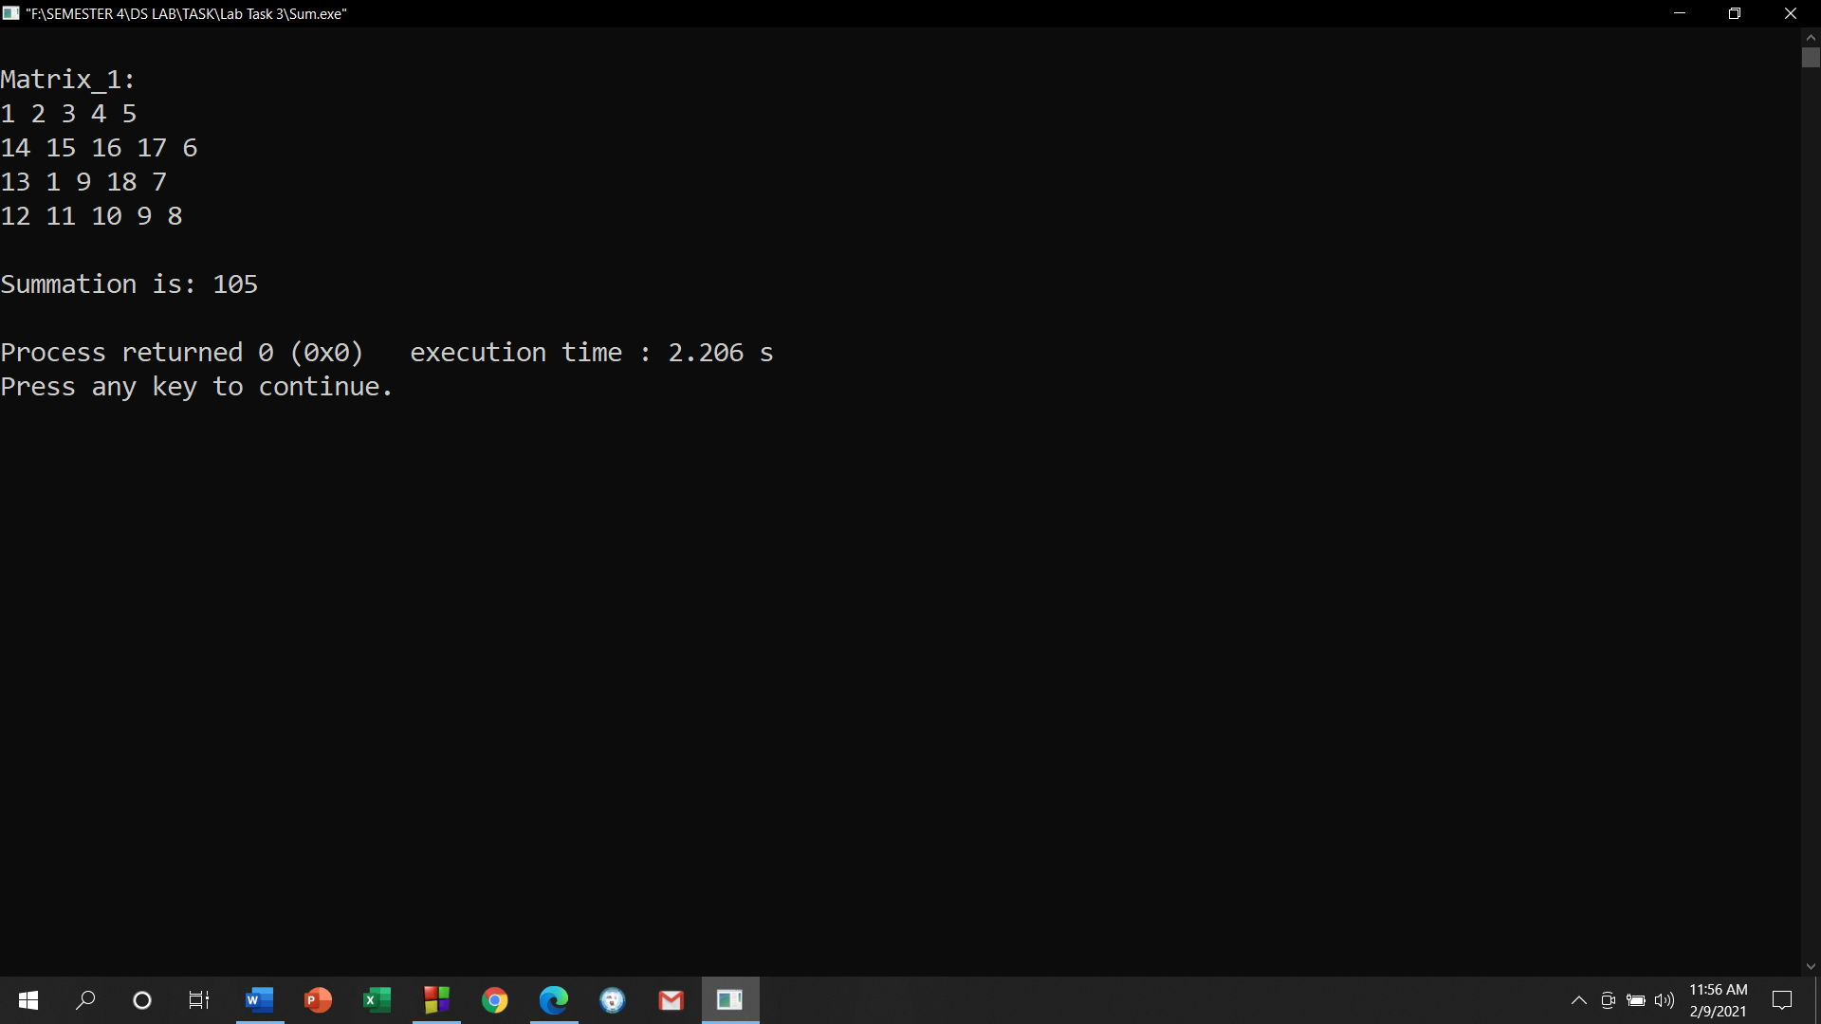

- Find the summation of the diagonal and anti-diagonal elements for the given array. Take input from user keyboard.

1 | 2 | 3 | 4 | 5
14 | 15 | 16 | 17 | 6
13 | 20 | 19 | 18 | 7
12 | 11 | 10 | 9 | 8
21 | 22 | 23 | 24 | 25

For example,
Matrix_1:
1 2 3 4 5
14 15 16 17 6
13 1 9 18 7
12 11 10 9 8
21 22 23 24 25
Output:
Summation is: 123

Your code here:

#include <iostream>
using namespace std;

int main()
{
int r=5, d=5, a[r][d], sum=0, i, j;

cout << "Matrix_1: " << endl;
for(i = 0; i < r; ++i)
{
for(j = 0; j < d; ++j)
{
cin >> a[i][j];

}
}

for (int i = 0; i < r; i++) {
for (int j = 0; j < d; j++)
{
if (i == j || (i + j) == (d - 1))
{
sum+=a[i][j];
}

}
}

cout<<"Summation is: "<<sum;

return 0;
}

Your whole Screenshot here: (Console Output):

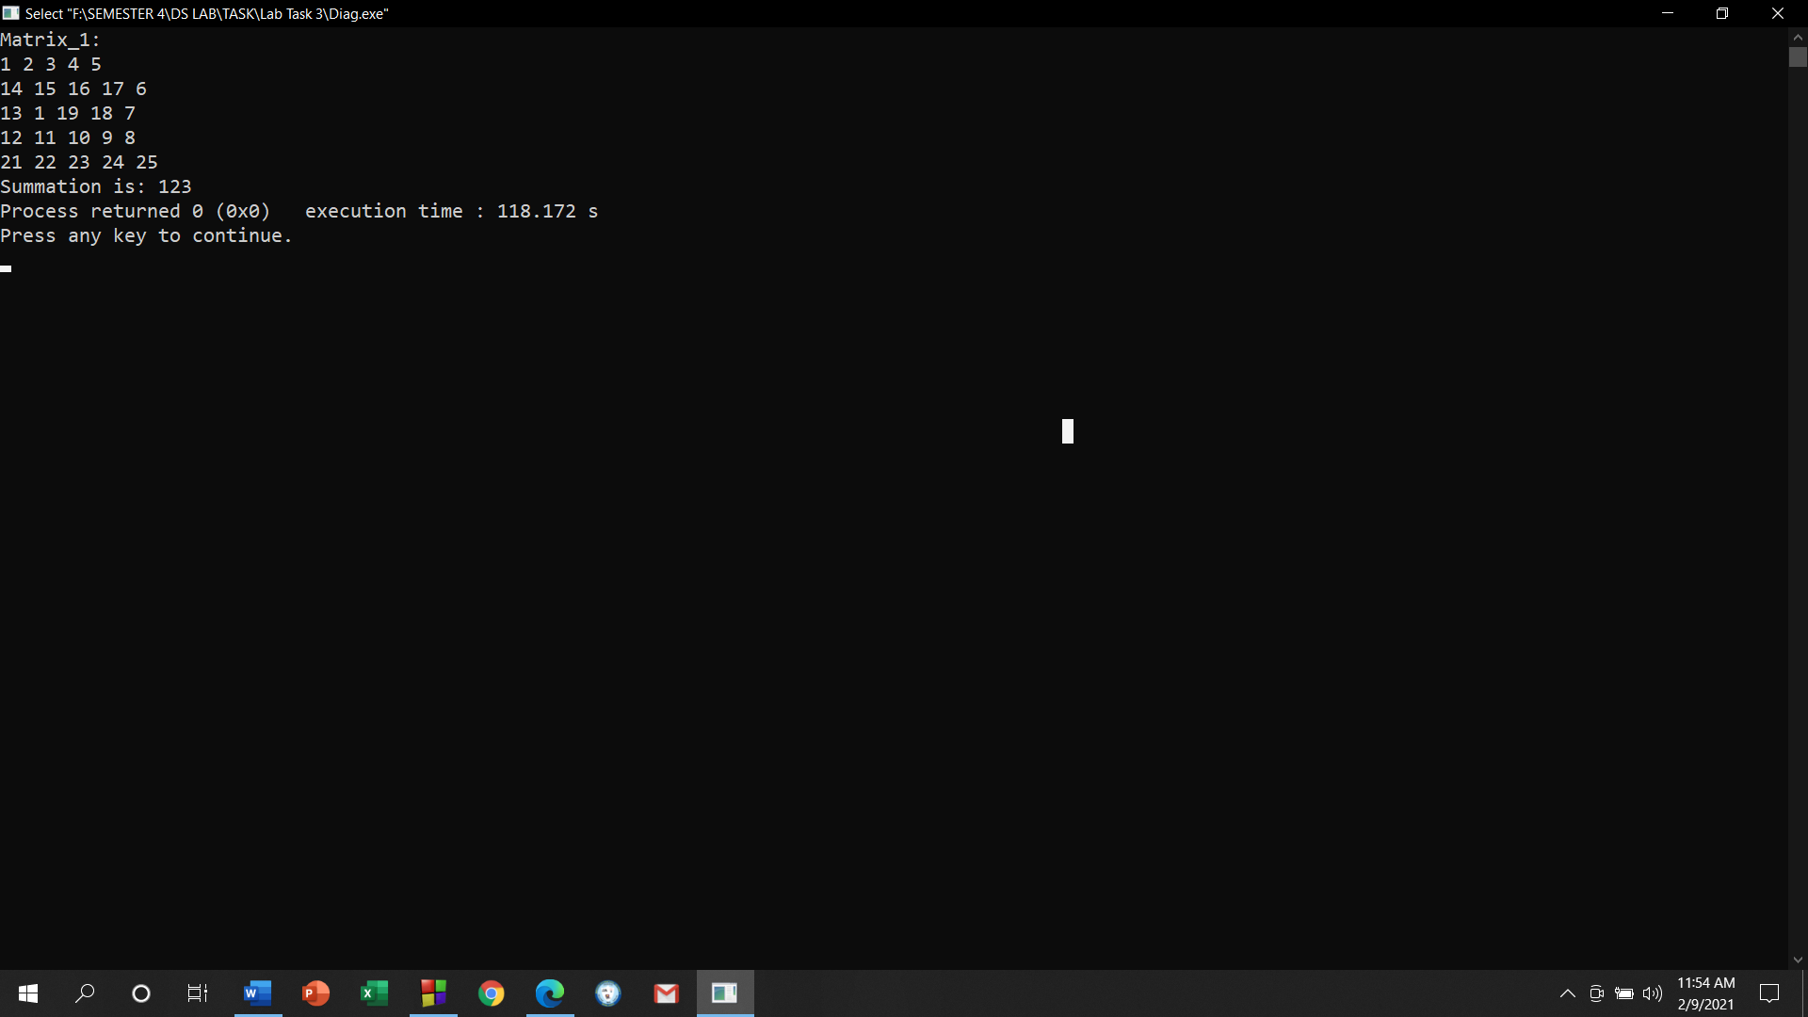

- Write a code that will create custom ciphers (encoded words) on strings. Follow this procedure:
  - Write a function named encode that takes TWO parameters, a string s and an integer j.
  - Skip j number of characters in the string and increase the ASCII value of the next character by 2.
  - Perform step (ii) throughout the string.
  - Return the converted string from encode function.
For example,
Sample String (s): I am a student
Sample Integer (j): 2
Converted String: I cm c svudgnt

Your code here:
#include <iostream>
using namespace std;
void encode(string s, int j)
{
int i;
for(i=j;i<s.length();i++)
{
s[i]=s[i]+2;
i+=j;
}
cout<<"\nConverted String : ";
for(i=0;i<s.length();i++)
{
cout<<s[i];
}
}
int main()
{
int j;
string s;
cout<<"Sample String (s): ";
getline(cin,s);
cout<<"Sample Integer (j): ";
cin>>j;
encode(s,j);
cout<<endl;
return 0;
}

Your whole Screenshot here: (Console Output):

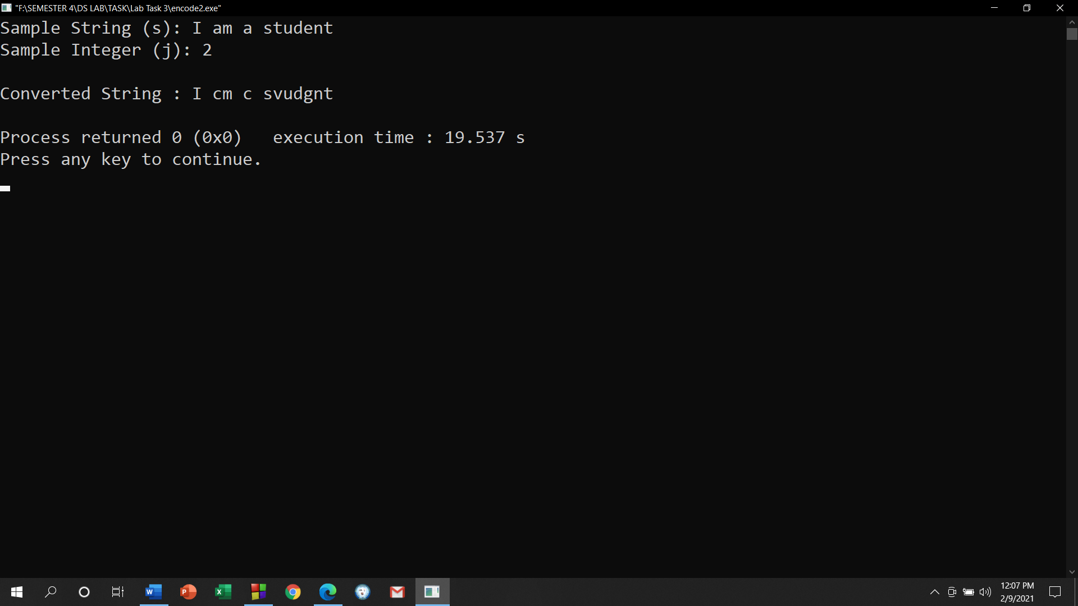

- Write a program with appropriate data structure to keep records of 10 students. Each student will have the following information:
  - Unique ID (you can use integer for this)
  - Number of Credits Completed
  - CGPA
Print all the student’s ID whose CGPA is more than 3.75.
Print all the student’s ID who has completed more than 50 credits.

Your code here:
#include <iostream>
using namespace std;
struct student
{
string id;
int cr;
float cg;
};
int main()
{
student arr[10];
for(int i=0;i<10;i++)
{
cout<<"Enter Students Details "<<(i+1)<<endl;
cout<<"ID: ";
cin>>arr[i].id;
cout<<"Credit: ";
cin>>arr[i].cr;
cout<<"CGPA: ";
cin>>arr[i].cg;

}
cout<<"\n\nThe Student's ID whose CGPA is more than 3.75 : ";
for(int i=0;i<10;i++)
{
if(arr[i].cg>3.75)
cout<<arr[i].id<<"; ";

}
cout<<"\n\nThe Student's ID who has completed more than 50 credits : ";
for(int i=0;i<10;i++)
{
if(arr[i].cr>50)
cout<<arr[i].id<<"; ";

}
cout<<endl;
}

Your whole Screenshot here: (Console Output):

